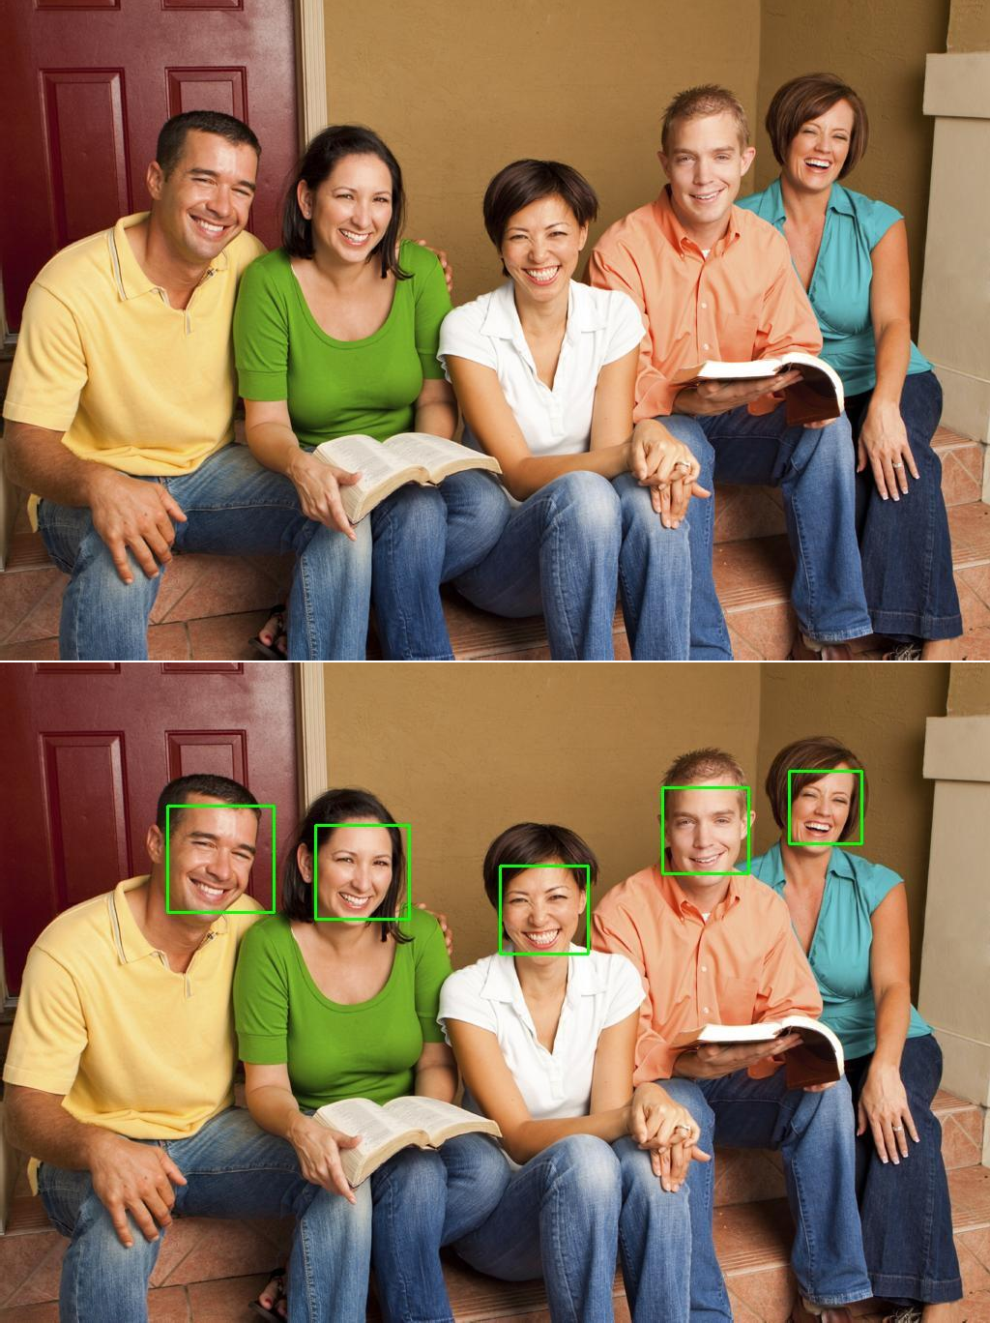

Following are the 3D morphed images of the cropped input images:

